



Ninth Session of
SOUTHEASTERN EUROPE CLIMATE OUTLOOK FORUM (SEECOF-9)
April-May, 2013

SEASONAL OUTLOOK FOR SUMMER SEASON 2013 FOR THE SOUTH EASTERN EUROPE AND CAUCASUS REGION (SEE&C)
Climate experts from WMO RA VI RCC Network Nodes on long-range forecasting (Meteo France, France and Roshydromet, Russia) and WMO RA VI RCC Network Node on climate monitoring (Deutscher Wetterdienst, Germany), UK Met-Office, Global Producing Centre ECMWF, International Research Institute for Climate and Society (IRI, USA), National Centers for Environmental Prediction (NCEP,USA), South East Europe Virtual Climate Change Centre (SEEVCCC, Serbia) and National Hydrometeorological Services of SEECOF region provided their valuable contribution to the successful implementation of SEECOF-9 by developing the relevant documents and providing scientific guidance and recommendations.
The SEECOF-9 comprised of the following Steps:
- Step 1: qualitative verification of the SEECOF-8 climate outlook for 2012-2013 Winter;
- Step 2: assessment of the current state of the climate including large-scale climate patterns worldwide and assessments of its likely evolution in the course of the next months;
- Step 3: building the consensus forecast for 2013 Summer season.
All relevant documentation is posted and updated in SEEVCCC web site: http://www.seevccc.rs

SEECOF- 9 CLIMATE OUTLOOK
FOR 2013 SUMMER SEASON

This prediction is based on output from dynamical models, statistical models and known teleconnections of large-scale climate features. Since the beginning of May near-neutral ENSO conditions have been established and are expected to continue during the summer season 2013. It can be noted that almost all dynamical models predict slight warming, but it is still close to neutral ENSO-conditions (below the El Nino threshold). EUROSIP plumes, in average, have close to normal conditions with a large spread, indicating a large uncertainty. The situation is similar in both tropical parts of the Atlantic Ocean. SST should be slightly warmer, but within near-normal conditions with large spread. Northern Indian Ocean is slightly warmer than normal, more or less everywhere. Taking into account all abovementioned facts, it could be said that the oceanic forcing is low, more or less everywhere. Thus, no teleconnection patterns seem to be present in the forecasts. At seasonal scales, predictability is limited for most of the European continent. South Eastern Europe, and especially its eastern part, could be an exception.

The maps show the probabilistic consensus forecast for tercile categories of anomalies of seasonal-mean temperature and precipitation, relative to the period 1981-2010.
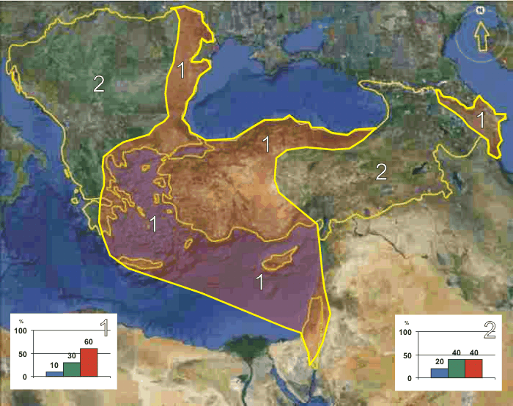
Figure 1. Graphical presentation 2013 summer temperature outlook
In summary, in the whole SEECOF region there is likelihood for above-average summer season temperature. There is less probability for exceeding the average summer season temperature in most of the Balkan Peninsula, eastern and southeastern part of Turkey and in the western parts of the Caucasus region (zone 2 in Figure 1), while there is higher probability for these above-average conditions in the Aegean Sea, Central and Eastern Mediterranean with the belonging coasts, as well as along the western and southern coasts of the Black Sea, in the western part of Turkey and in the eastern part of Caucasus (zone 1 in Figure 1).

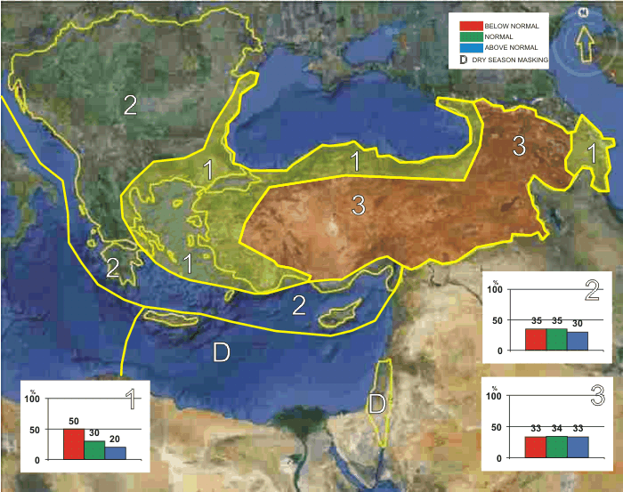
Figure 2. Graphical presentation 2013 summer precipitation outlook

Uncertainties in regional predictions are larger for precipitation than for temperature. In the Aegean and Black Sea with hinterland and in the eastern part of Caucasus region summer season precipitation totals are more likely to be below average (zone 1 in Figure 2), while in the most of the Balkan Peninsula, Pannonia Plain, Adriatic and Ionian Sea with hinterland, along the southern coasts of Turkey and Cyprus summer season precipitation totals are likely to be near- or below- average (zone 2 in Figure 2). In the mountainous part of the Caucasus region and in the central and eastern part of Turkey (zone 3 in Figure 2), the uncertainty is large: probabilities for below-, near- or above- average conditions are approximately equal. It must be emphasized that it might be possible that some parts, especially mountainous ones, might locally have near- or above- normal summer season totals, due to the episodes of enhanced convection with high intensity rainfall. Also, it must be noted that due to dry season masking there is no use forecasting summer season precipitation totals in the Central Mediterranean, as well as in the southern and eastern parts of the Eastern Mediterranean with hinterland.
Any further advice on the forecast signals, shorter-range updates and warnings will be available throughout the summer from the National Meteorological Services, along with details on the methodology and skill of long-range predictions.

* The graphical representation of climate outlook in this statement is only for guidance purposes, and does not imply any opinion whatsoever concerning the legal status of any country, territory, city or area or of its authorities, or concerning the delimitation of its frontiers or boundaries.

Weather outlook for summer 2013 in Serbia

Overall, summer 2013 is expected to be warmer than average across entire Serbia, although not as 2012’s scorcher, which ranked as the warmest ever since the meteorological observations in Serbia began.
Summer 2013 will characterize below to near average precipitation sums nevertheless without lengthy dry periods as last year. Furthermore, it is noteworthy to mention that despite these conditions, there will also be a chance of more rainfall in the mountain areas due to the formation of the convective cloud cover and the occurrence of heavy showers.

According to the Climate Watch, June 2013 is expected to be colder than average. It is forecast that during June, July and August the number of tropical days, exceeding 30 C° will range between 22 to 38, 34 and 4 in Belgrade and mountain areas, respectively. The number of tropical nights (with minimum air temperature above 20 C°) will amount to 16 in Belgrade and 7 elsewhere (apart from the mountain areas).

APPENDIX A: Contributors to SEECOF-9

- World Meteorological Organization
- Met Office, United Kingdom
- International Research Institute for Climate and Society, United States of America
- European Center for Medium Range Weather Forecast
- Meteo France, Republic of France
- Federal Service for Hydrometeorology and Environmental Monitoring, Russian Federation
- Deutscher Wetterdienst, Federal Republic of Germany
- National Center for Environmental Prediction, United States of America
- South East European Virtual Climate Change Center hosted by Republic Hydrometeorological Service of Serbia, Republic of Serbia
- Armenian State Hydrometeorological and Monitoring Service, Republic of Armenia
- National Hydrometeorological Department, Republic of Azerbaijan
- National Institute of Meteorology and Hydrology, Republic of Bulgaria
- Meteorological and Hydrological Service, Republic of Croatia
- Meteorological Service, Republic of Cyprus
- Hellenic National Meteorological Service, Greece
- The National Environmental Agency of Georgia, Georgia
- Meteorological Service of the Republic of Hungary, Republic of Hungary
- Israel Meteorological Service, State of Israel
- Republic Hydrometeorological Institute, Former Yugoslav Republic of Macedonia
- State Hydrometeorological Service, Republic of Moldova
- Hydrometeorological Institute of Montenegro, Montenegro
- National Meteorological Administration, Romania
- Federal Hydrometeorological Service of the Federation of Bosnia and Herzegovina, Federation of Bosnia and Herzegovina, Bosnia and Herzegovina
- Republic Hydrometeorological Service of the Republic of Srpska, Republic of Srpska, Bosnia and Herzegovina
- Republic Hydrometeorological Service of Serbia, Republic of Serbia
- Meteorological Office, Republic of Slovenia
- Turkish State Meteorological Service, Republic of Turkey

